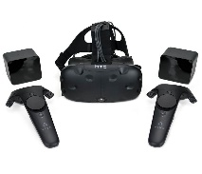
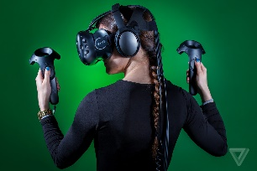
VIVE Virtual Reality
How to get it set up:
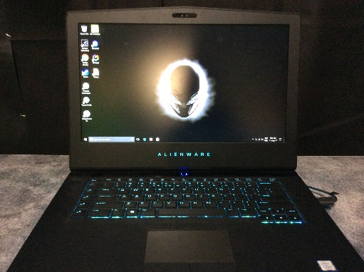
- If the laptops are not on, log on, with Wallarano5055 as the password.
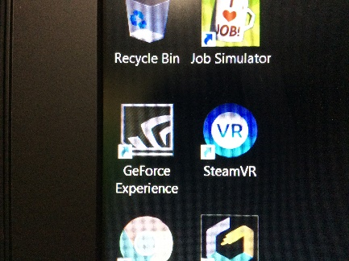

- Click on SteamVR
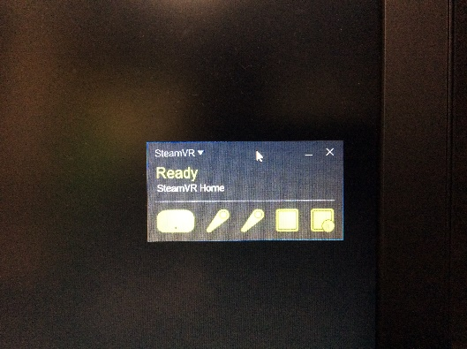

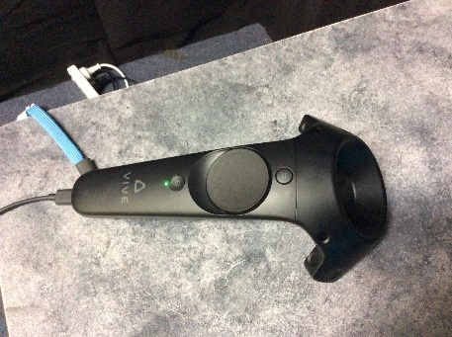
- Wait for this small panel to appear. Each part of the system should turn green. Take the hand controllers off the chargers, they have a small round button – press this to turn them on, they should get a small green light appear on them.
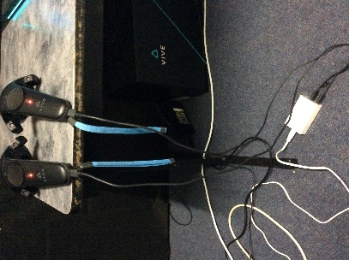

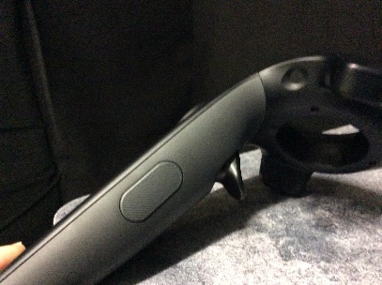
- When it is time to pack up, shut down the laptops, and put the controllers back on charge.

- Basic hints: the hand controllers have a ‘trigger’ underneath them, that is used a lot in the activities, plus a large round disc like button that can be swiped on the top of the controller.
- Have the students work in groups of 3 – one using the headset, one to be a ‘spotter’ -watch the student using the headset, (stop them from walking into things, making sure the cord doesn’t wrap around their neck if they turn around. The third student can watch what is happing on the laptop screen. I usually give them 3-5mins each, then get them to rotate roles.
- The wii can be set up for students to play while they are waiting for their turn, but I found they were more excited to play the wii than use the VIVE headset, so instead, had them work in groups of 3.
Job Simulator:
ABOUT THIS GAME
Players participate in simulated jobs in a job museum run by robots resembling floating CRT computer monitors with faces. The jobs are represented as tongue-in-cheek approximations of real occupations: "Auto Mechanic", "Gourmet Chef", "Store Clerk" and "Office Worker". Accompanied by a computer character who provides exposition and instructions, players perform tasks associated with that occupation, some realistic and others comical. For example, in the "Office Worker" simulation, players engage in activities like evaluating new employees and transferring calls, but are also called upon to eat doughnuts, share photos at the water cooler, and participate in other office tasks.
Using the motion controllers of the HTC Vive to represent their hands, players interact with the virtual environment similarly to how they would in real life. Most objects within the player's reach can be interacted with - many can be picked up and manipulated, while fixed objects such as keyboards and appliances will have buttons, levers, or dials that the player can utilize. After completing a certain amount of tasks, the player is offered to go back to the museum or continue interacting with the environment. Once the player completes all four job simulations, they're offered a variety of modifiers that change the physics of the gameplay.
The player is often afforded a large amount of creative freedom in how they complete a task. For example, when cooking pizza in the chef simulation, players can choose any ingredient they can reach, such as bacon, eggs, apples, or cookies to use as pizza toppings. When performing car repairs in the auto-mechanic simulation, players can choose what style of parts to use as replacements (for example, when replacing a flat tire, the player can choose from any of 9 available tire styles) and are allowed to perform repairs and replacements that aren't requested by the customer. The player is also free to mess around with the various objects in their reach, such as throwing things in trash cans or at robots, eating food lying around or taking the sunglasses off a customer.
I would definitely have a play with this before getting younger students to play it. It took me a while to even work out what I was supposed to be doing.
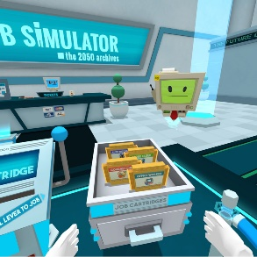
At the start, this is where you pick up the cassettes (for the different jobs) then you put them in the machine on the left

Here are some videos to watch (if you don’t’ have time to try playing it yourself) – they all go for 20mins or more, but you could just watch some of it, might even be handy to show a little bit to the students to give them an idea of what to do. They are done by a gamer (who you can see in the top corner of the screen). He tries out the 4 basic games:
https://www.youtube.com/watch?v=YRn-OaUso1c Store Clerk
https://www.youtube.com/watch?v=-DSr613ZZ80 Car Mechanic
https://www.youtube.com/watch?v=0C7nqCXvaoo Gourmet Chef
https://www.youtube.com/watch?v=bUf7Pck1WLM Office worker
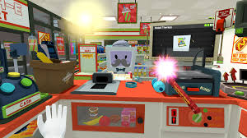

When you are in one of the ‘jobs’ your controllers appear as large, white gloved hands.
You can explore the place around you – pick things up, open cupboards, cook hot dogs at the 7Eleve (Store Clerk).

To be honest, I haven’t played with these much. I think the younger chn might like the chef or clerk one, but it takes a bit of practice to work out what you are required to do. Maybe for their first time they could just explore the kitchen / store and see what they can do, before they try to serve customers etc.

Tilt Brush:
From the website:
Tilt Brush lets you paint in 3D space with virtual reality. Unleash your creativity with three-dimensional brush strokes, stars, light, and even fire. Your room is your canvas. Your palette is your imagination. The possibilities are endless.

https://www.youtube.com/watch?v=TckqNdrdbgk
This is a great intro video – only goes for a minute – shows some of the things you can do – show it to the students on one of the laptops.

My suggestions (or what has worked well).
- Definitely take 30mins or so to go and use the VIVE by yourself if you have never used it before – makes it much easier to help students, explain the basics, if you have already played with it. (Maybe try the tutorial – see below).

For a quick tutorial
On your palette, go to Tools > More > Tips ‘N Tricks.
This will run you through an overview of your Tilt Brush controllers and where the various buttons are.

- With the younger grades (I did this with grade 2’s, but think it would be appropriate for all ages):
  - I put on the headset, showed them the basics, while they watched the screen on the laptop.
  - They should be able to: hold down the trigger to ‘paint’ or draw, change colours on the palette, (and maybe even change brushes), use the rubbish bin to delete their work in readiness for the next student
  - Give them 5 mins each just to play around, see what they can do, draw something etc, get the hang of using the basic tools.
  - For their next turn, let them do what they like again, but I found some need a prompt of what to ‘draw’, so maybe suggest they;
    - Write their name in the air
    - Write out the alphabet
    - Draw a simple animal like cat, dog etc.
    - Draw a picture of themselves, or family member
    - Try drawing something and see if the others in your group can guess it
    - Maybe the first person could start a picture, then the next child adds to it etc (instead of clearing everything off after each child).
    - See what other ideas the kids can come up with.
  - It is really more about them exploring the different tools, changing brushes, colours etc.

Some basic info:

Painting with Tilt Brush
On your painting controller, use your index finger to pull the trigger.
Hold the trigger down and move the controller to paint.
Note: You can switch which hand is your painting controller and which is your palette controller by tapping the bottoms of the two controllers together. This is great to use if a right and left handed person are sharing controllers.

Activate your paint palette
On your palette controller, use your thumb to swipe left or right across the thumbpad (HTC Vive)
This will activate the palette.
Using your painting controller, angle your controller towards the palette in order to select items on the palette.
Focus the pointer and press trigger to make selections.
Change the width of your brush strokes
To change the width of your brush strokes:

On your painting controller, slide your thumb left or right along the thumbpad (HTC Vive)
Sliding or toggling left will make the brush stroke finer. Sliding or toggling right will make the brush stroke larger.
Undo & Redo shortcuts

Using the Tilt Brush palette
https://support.google.com/tiltbrush/answer/6389713?hl=en&ref_topic=7074683
This link will take you to lots of information about using the tilt brush palette (too much to copy and paste here). Below is some of the most important bits:
Brush picker
To select a brush:
- Position your controller on the the brush stroke you want.
- Press the trigger to confirm the brush stroke.
- Your brush type, color and size will be copied.
- To disable the brush picker, select the icon again.

Eraser
You can use the eraser tool to erase entire brush strokes. To select the tool:
- Point your painting controller towards the palette and select the eraser .
- Position the tool anywhere on the brush stroke and press the trigger to erase.
- To disable the eraser, select the icon again.
Note: To erase your last brush stroke quickly, you can also use Undo. To use Undo, press the left side of the palette controller’s disk. You can also use Undo if you accidentally erase a brush stroke.

Google Earth:
ABOUT THIS GAME
Google Earth VR lets you explore the world from totally new perspectives in virtual reality. Stroll the streets of Tokyo, soar over the Grand Canyon, or walk around the Eiffel Tower. This virtual reality app lets you see the world’s cities, landmarks, and natural wonders. You can fly over a city, stand at the top of the highest peaks, and even soar into space. Earth VR comes with cinematic tours and hand-picked destinations that send you to the Amazon River, the Manhattan skyline, the Grand Canyon, the Swiss Alps, and more.

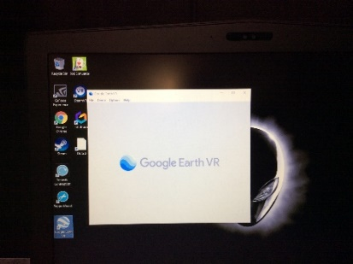
Tips:
I have found that often this one does not ‘show’ on the laptop screen, what the student is seeing through the headphones. So you might think it is not working when you load it – make sure you put the headset on (or get a student to) – and see if you / they can see anything. You can try restarting the computer, sometimes this helps, other times it doesn’t, just means no one can see what the student is seeing through the headset. So you could get their partners to ask them questions – what are you seeing etc.

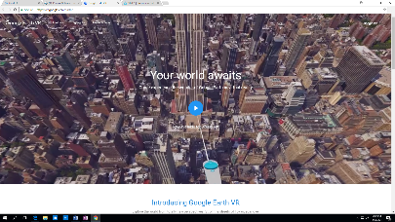
I would maybe start with this website: https://vr.google.com/earth/
From this home screen, click on the blue arrow, which opens ups a short 1min video to watch, both for yourself, and as an intro for students.
https://youtu.be/SCrkZOx5Q1M (link to the same video)

Scroll down further on this home screen – there is info / an example of how you can ‘walk around’, ‘fly’ or ‘browse’ to get around google earth. Scroll down a little bit further, and there are 6 examples under the heading of Go Anywhere - try clicking on one of them, you can click on the screen, drag the mouse to rotate around – gives you a bit of a feeling of what it is like for the student wearing the headset.

Some other handy hints:

Change the time of day and track Earth's rotation
If you jump into Google Earth VR and see that it's dark outside, you might be wondering how to change the time of day. Easy! Just point your controller at the sky, hold the Drag button, and move it around. You'll notice there's a line around Earth; that's the path the sun appears to take in our sky.

