VIVE controller functions in Google Earth 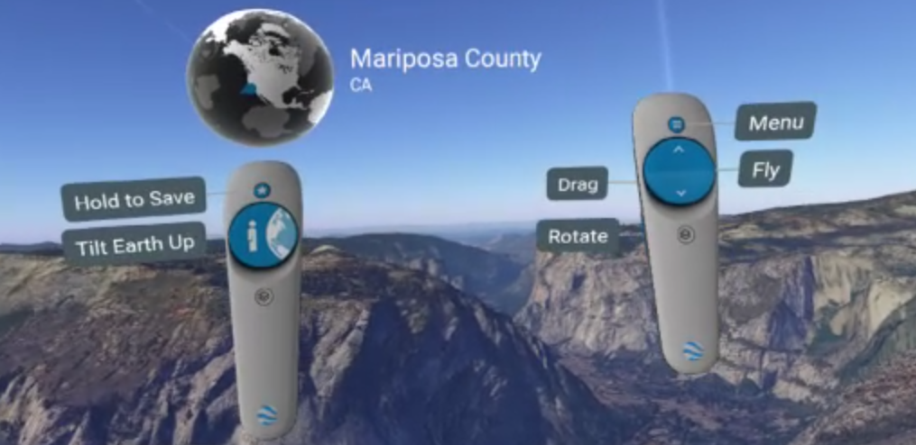

How to get to street view in Google Earth by searching a city
- Double click on Google earth icon.

- Click Play Game with VIVE controller.

- Follow the tutorial to learn what each function on the controller does.
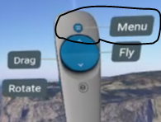
- Click Menu.

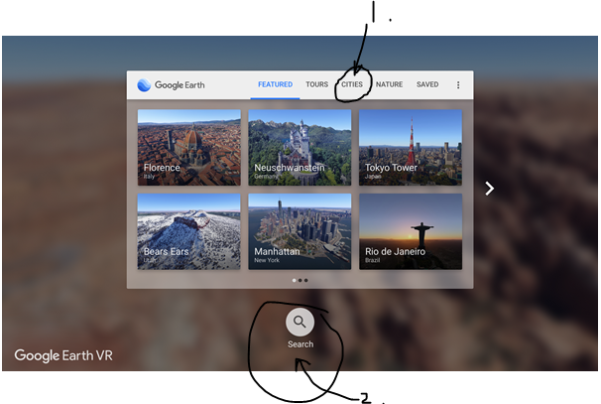
- Click cities. Then Search.

- Point the controller to sellect the letters to spell the city you want. Eg: Florence.
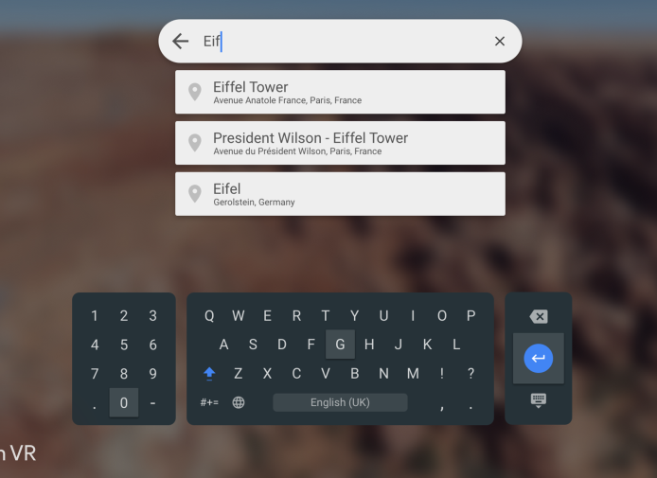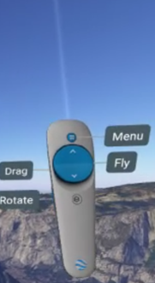
- When you are at the city move closer (make sure it is under your feet).

- Look for the Oracle (sphere/circle over the left controller). Use your right hand controller to point the beam at the oracle and click on it/select it. 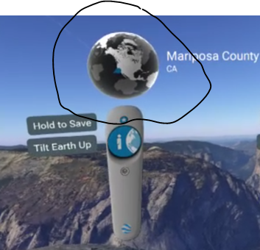

- Now you should be in Street View (virtually in the city) you can turn around to see what it looks like.

