Digital Sandpit: 3D Printing

Session One: | Ask students what they know about 3D printing – what can it do? Have they seen one before? How do they work?  Show them one of these videos (only go for a couple of mins each):  https://www.youtube.com/watch?v=Llgko_GpXbI  https://www.youtube.com/watch?v=9hRhVGfyPrM  https://www.youtube.com/watch?v=yeUiXPO2mb4  Take students them in and show them where our 3D printers are – let them have a bit of a look – any questions?  Come back to the lab, get students to log on to a computer (using normal username and password) eg. con0015 Lcred04!  Give each student a copy of the Guide Sheet for Students – Lesson 1 – it has all the steps required for making an account (wont list them all here again). Older students should be able to follow them independently, younger students would benefit from getting one of the students demonstrating the step by step process, using the laptop and data projector.  Once accounts are set up, students click on Learn, which takes them through 5 basic lessons, that cover: Learning the Moves, Camera Controls, Creating Holes, Scale, Copy & Paste, Key Ring, Letters and Die on the Workplane.  After each lesson, their work is automatically saved. They won’t get them all done during today’s lesson (it took me about 30mins to get thru them all successfully).  (I found my brightest gr 4 kids got thru 3 of the 5 lessons this week)
Session Two: | Get students to log on to a computer as per last week.  Go to the Tynker website as per last week – via Quick Link – Coding tab, or typing in website address into Google Chrome  Give each student a copy of the Guide Sheet for Students – Lessons 2 Onwards.  Remind them that they do not need to create a new account this week – they just need to log in to their account and continue on with the lessons. If you finish early, sit with someone else and guide them through the lessons. (Should be able to get them finished this lesson).  I found that some of the weaker students really struggled with following the instructions for the 5 lessons, deleted stuff, I couldn’t get it back etc etc. Important to pair them up with a more able student  So maybe if time this lesson – Chris showed me a simple activity that sort of combines the skills from the 5 lessons, I could demo this using laptop, and then get kids to follow;  Add a red base block, resize it to a large rectangle, add a pyramid on top, resize, to look like a bit of a house, get chn to right click and hold mouse down to check the view from all angles, add another block or two, try putting in hole for a door etc.  Then (if time – or do next week?):  Time to think about what you are going to design and print out using the 3D printer?  Brainstorm some ideas of what you might like to create, have a look at the examples on the little table (while it is there), maybe google ‘easy things for kids to make with 3D printer’ – nothing too complicated, as they will only have 2 sessions to create it. Also try looking at the ‘project’ section
Session Three: | Get students to log on to a computer as per last week.  Go to the Tynker website as per last week – via Quick Link – Coding tab, or typing in website address into Google Chrome  Give each student a copy of the Guide Sheet for Students – Lessons 2 Onwards.  Hopefully they are getting faster at getting logged on to the Tinkercad website!!
Session Four: | Get students to log on to a computer as per last week.  Go to the Tynker website as per last week – via Quick Link – Coding tab, or typing in website address into Google Chrome  Give each student a copy of the Guide Sheet for Students – Lessons 2 Onwards.  Hopefully they are getting faster at getting logged on to the Tinkercad website!!

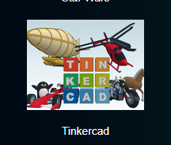
3D Printing – Guide Sheet for Students - First Lesson:
First time using the website, you need to create an account. This is how to do it:
Go to Quick Links – Coding Tab – link to Tinkercad website is down the bottom of the page.
Or: you can go to Google chrome, and type in the website address: https://www.tinkercad.com
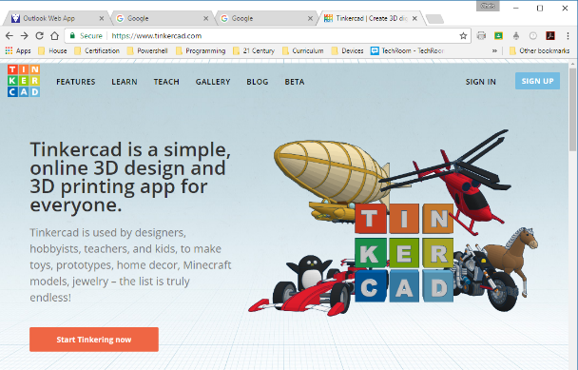

1. Click here on Sign In
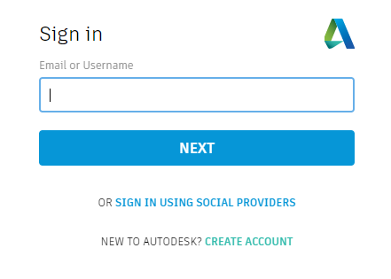
2. You will see this Sign In screen.
Click on SIGN IN USING SOCIAL PROVIDERS

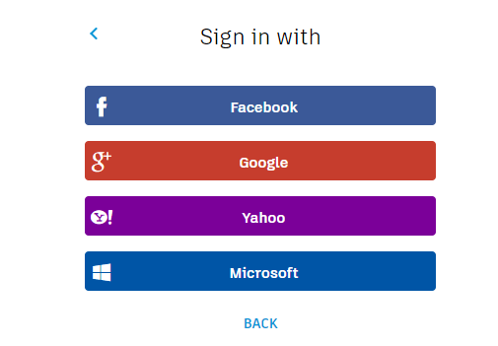
3. You will see this screen
Click on Google

Email address is your
username@wallarano-ps.vic.edu.au
For example
for0006@wallarano-ps.vic.edu.au

Password is the same password that you use to log on to the computers:
Eg Lcred04!
Make sure you type these in carefully, as you will need them
in future lessons to log in to your account!!

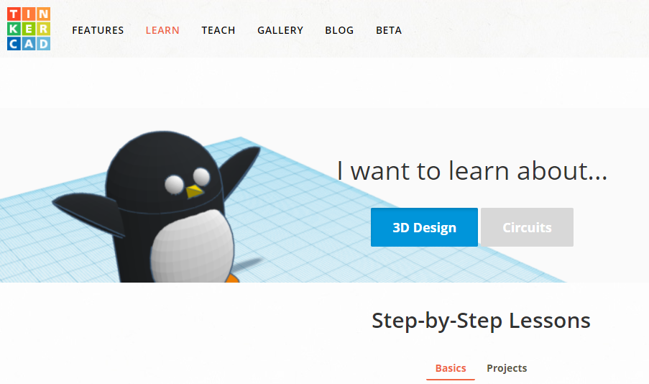
Once your account has been set up, click on Learn
And then click on 3D Design

Scroll down a bit and try the Learning the Moves lesson.
Instructions are down the left hand side of the screen.
Follow them (they are pretty easy), and after each one, move on to the next one.
There are 5 lessons in total. It automatically saves your work after each lesson.
Do as much as you can today, and then you will continue on with them next lesson.

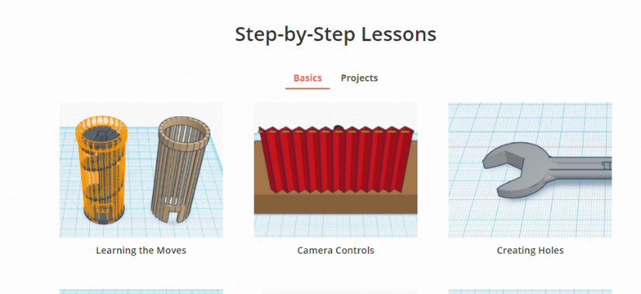

3D Printing – Guide Sheet for Students
Second Lesson Onwards:
Go to Quick Links – Coding Tab – link to Tinkercad website is down the bottom of the page.
Or: you can go to Google chrome, and type in the website address: https://www.tinkercad.com
You need to log on like you did during the first session;
Click on Sign In
Click on Sign in using social providers
Click on Google
Type in your email address eg con0012@wallarano-ps.vic.edu.au
Type in the password you used last time eg Lcred04!

Click on the LEARN button at the top, and you can continue on with the lessons you started last time.
When you have finished the 5 lessons, it is time to decide what you are going to design and print out using the 3D printer!!!
For some ideas (and tutorials that you can follow step by step):
Click on the LEARN button at the top of the screen, click on Projects, scroll down and click on the blue button that says See More Projects
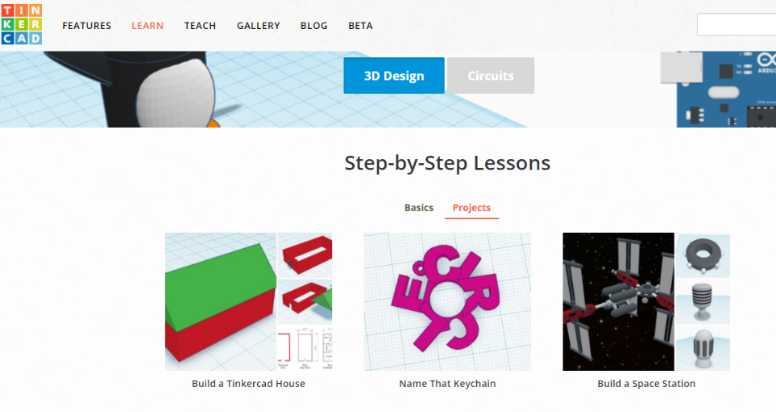
Look through the projects and pick one (nothing too difficult!! – you only have 2 sessions to create it).
Select the project that you want to make, follow the steps on the left hand side carefully. See the example on the next page – I made a keyring of my first name:

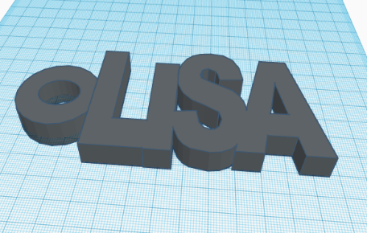
You don’t have to follow one of these tutorials, you might have your own ideas, and can just start creating something – maybe chat with someone else and share your ideas.
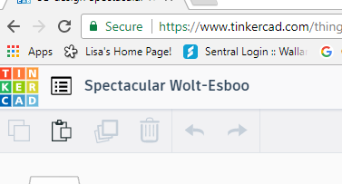

Make sure your work is saved regularly.
To do this, click in this box up near the top, and type in a relevant name for your product. Use your first name, room number and what it is. For eg. Lisa 4.4 keyring.
You will continue working on it next lesson too.
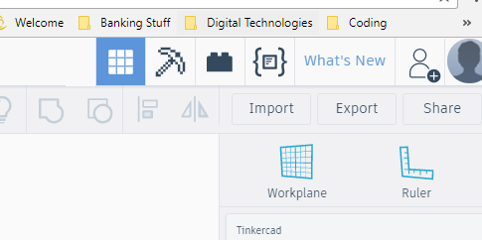
Handy hint:
You can click on this ruler, drag it over on to the workplane, next to your creation. It can help with sizing objects.

When your creation is finished and ready to print:
- Save your work again
- Click on Export
- Click on STL
- Then you have to save a copy
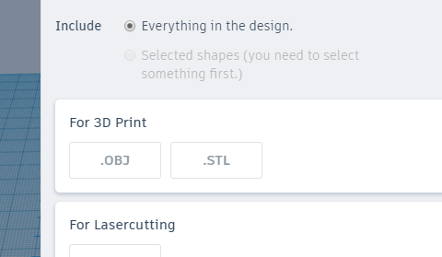
of it in the Public Drive – Digital Sandpit
folder:
Your work will appear down the bottom on the tool bar. Click on the arrow next to it, click on Show in Folder. Then you can right click this, copy and paste it into the 3D Printing folder.
- Chris will then use the 3D printer
and print your creation for you!!!

